DEFRA MINISTERS 2017

The Rt Hon Michael Gove MP
Secretary of State
• oversight of EU exit work and the overall policy programme
• international relations
• emergencies
• departmental administration
E: secretary.state@defra.gsi.gov.uk
T: @michaelgove
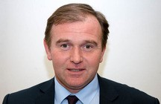
Mr George Eustice MP
Minister of State
• food and farming, including CAP (Common Agricultural Policy), apprenticeships, exports, and bovine TB (tuberculosis) policy
• fisheries
• better regulation
• science and innovation
E: ps.george.eustice@defra.gsi.gov.uk

Dr Thérèse Coffey MP
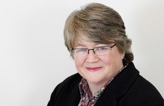
Parliamentary Under Secretary of State (Environment and Rural Life Opportunities)
• natural environment, including biodiversity, the marine environment, and international wildlife trafficking
• rural life opportunities, covering rural childcare, education and skills, and health
• floods, water and waterways
• air quality
• resource and environment management
E: ps.therese.coffey@defra.gsi.gov.uk
T: @theresecoffey
Lord Gardiner of Kimble
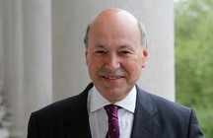
Parliamentary Under Secretary of State (Rural Affairs and Biosecurity)
• rural affairs, including broadband and mobile
• biosecurity strategy, including endemic and exotic plant and animal disease, invasive alien species and Kew Gardens
• animal health and welfare
• commercial projects
• landscape, including litter and national parks
• climate change adaptation
• National Pollinator Strategy
• all Defra parliamentary business in the House of Lords
E: ps.lord.gardiner@defra.gsi.gov.uk

